APP DEV AND EMERGING TECHs

Jericho Bruce Rivero | BSIT

Activity 4

Make a Python program that will display the elements of the List Fruit and its arrangement in backwards. Elements of List Fruit are Apple, Banana, Cherry, and Durian.

Display the before and after.

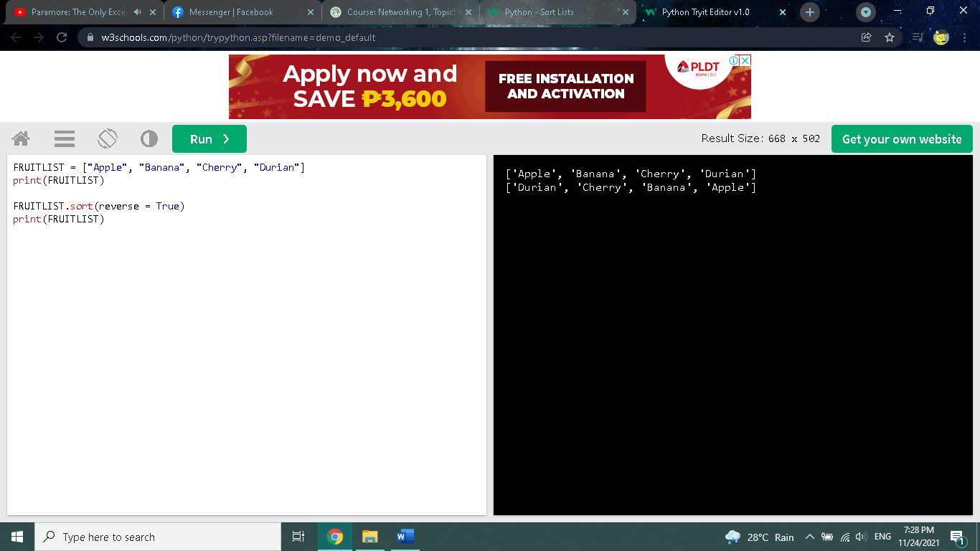



FRUITLIST = ["Apple", "Banana", "Cherry", "Durian"]

print(FRUITLIST)

FRUITLIST.sort(reverse = True)

print(FRUITLIST)